Student: _______________________________________________________

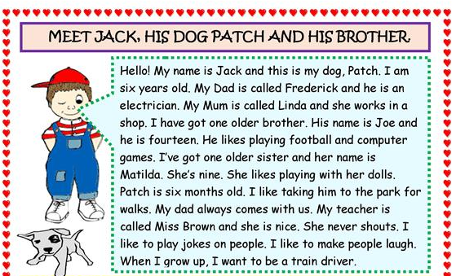

Answer the questions **TRUE or FALSE** : **T** or **F**

1. Jack is six years old. ( T )
2. He is English. ( T )
3. Jack’s dog’s name is Patch. ( T )
4. Jack’s dad is a teacher. ( F )
5. Jack’s mom works in an Office. ( F )
6. Jack hás one younger brother. ( F )
7. His sister Matilda likes playing with her balls. ( F )
8. His brother Joe likes playing football and computer games. ( T )
9. He likes taking Patch to town. ( F )
10. Dad sometimes goes with them. ( F )
11. His teacher Miss Brown is Nice and never shouts. ( T )
12. When He grows up, Jack wants to be a farmer. ( F )
13. Joe is forty years old. ( F )
14. Miss Brown is very angry. ( F )
15. Jack makes the people cry. ( F )

And you ? HOW OLD ARE YOU ? I’m sixteen

DO YOU WORK ? No, I have only sixteen years, it would be a crime.

WHERE DO YOU LIVE ? In my house, at Escola Agrícola.

WHAT DO YOU WANT TO DO ? I want be a Chemistry engineer in the future

DO YOU HAVE PETS ? Yea, I have a dog called Jorginho.

*Teacher Viviane !*

***What I understand about the teacher story.***

*Somewhere far, far away from here, lived a group of people that were happy, they lived in a beautiful place, with a little lake with colorful fish, birds singing and have a lot of different flowers of different colors, rabbits jumping around the place, but suddenly, in one day, a black hole arised, a deep abism, all the people that lived there been scared, everything seemed to end. BUT THEN.*

*A LIGHT, LIGHT FROM THE END ARISE, the light say: “Open your eyes, i will save you, don’t be scared.”*

*Then the light destroy the black hole and the people can live together and happy again.*

*This story teach us that even with a difficult problem, we shoudn’t lost the hope, we must believe in yourself that the problems will be resolved.*

***Present contínuos***

***1)****Anna is cooking a strange food.*

*Anna was cooking a strange food.*



2)Philip is riding a bike really faster.

Philip was riding a bike really faster.

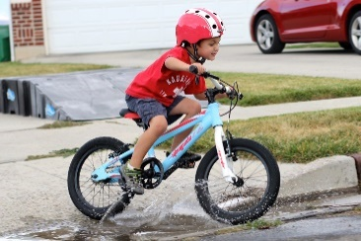

3)Margaret is playing badminton.

Margaret was playing badminton.

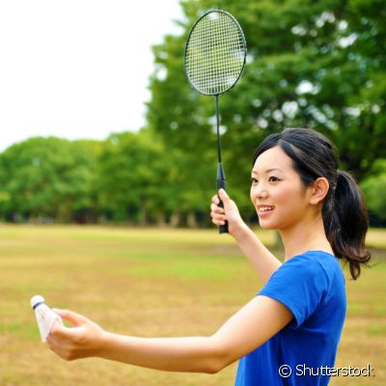

*4)Ben is talking with a person who him falling in love.*

*Ben was talking with a person who him falling in love.*



*5)Tina is watching tv.*

*Tina was watching tv.*



*6)The dog is eating on the bowl.*

*The dog was eating on the bowl.*



*7)Bill is playing soccer.*

*Bill was playing soccer.*

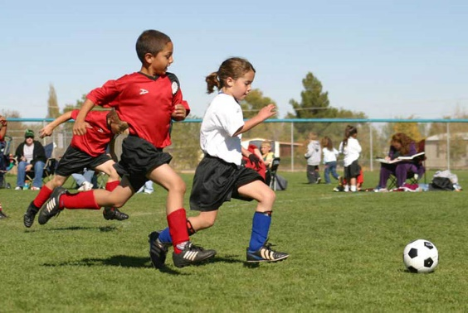

*8)Bob is sleeping hard.*

*Bob was sleeping hard.*



*9)Jim and Sheila are sunbathing.*

*Jim and Sheila were sunbathing.*



*10)Mick is washing your new car.*

*Mick was washing your new car.*

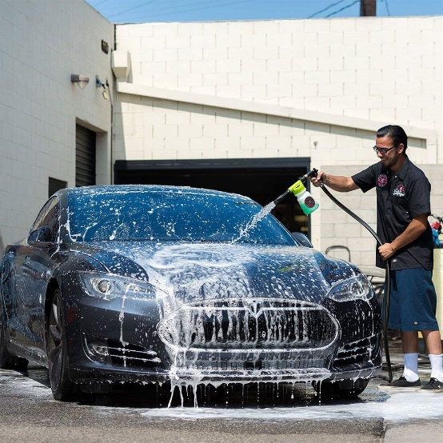

*11)Anne is doing her work until late of night.*

*Anne was doing her work until late of night.*



*12)Jill and Nick are having dinner at a restaurant.*

*Jill and Nick were having dinner at a restaurant.*



*13)Tim is painting his wall.*

*Tim was painting his wall.*



*14) Diana is swimming in pool of club.*

*Diana was swimming in pool of club.*

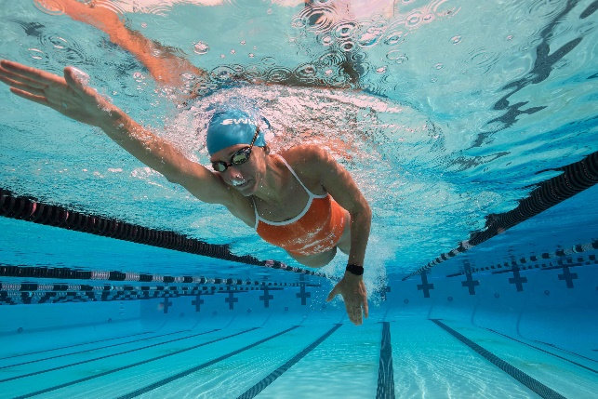

*15)Sue is reading a newspaper when waiting her son in english course at proway.*

*Sue was reading a newspaper when waiting her son in english course at proway.*



STORY ABOUT THE SEA TURTLE

Once upon a time a turtle called Candy saw a plastic bag in the ocean, then she gone to plastic bag for eat it. After eat the plastic bag stayed stuck around her head.

At the beach, a group of teens see a lot of plastic in sand, when they seen candy with the plastic bag around of her head and they call a people from projeto tamar to help Candy.

The man from Projeto Tamar take candy to get her to the project to help her.

After all, the group of teens decide to clean the beach.

1. A turtle
2. Green
3. Eat
4. Plastic
5. Yes, it is.
6. Yes, they are
7. Yes, they do
8. It is in Brazil
9. Yes, she is